

Mawlana Bhashani Science and Technology University

Lab-Report

Lab Report No: 10
Lab Report Name: Implementation of Round Robin Scheduling Algorithm.
Course code: ICT-3110
Course title: Operating System Lab
Date of Performance:
Date of Submission:

Submitted by Submitted To
Name : Maskur Al Shal Sabil
ID: IT 18021
3rd year 1st semester
Session : 2017-2018
Dept of ICT
Nazrul Islam
Assistant Professor
Dept. of ICT,
MBSTU.

Lab Report No-10: Implementation of Round Robin Scheduling Algorithm

What is Round-Robin Scheduling?
The name of this algorithm comes from the round-robin principle, where each person gets an equal share of something in turns. It is the oldest, simplest scheduling algorithm, which is mostly used for multitasking.
In Round-robin scheduling, each ready task runs turn by turn only in a cyclic queue for a limited time slice. This algorithm also offers starvation free execution of processes.

Characteristics of Round-Robin Scheduling
Here are the important characteristics of Round-Robin Scheduling:

- Round robin is a pre-emptive algorithm
- The CPU is shifted to the next process after fixed interval time, which is called time quantum/time slice.
- The process that is preempted is added to the end of the queue.
- Round robin is a hybrid model which is clock-driven
- Time slice should be minimum, which is assigned for a specific task that needs to be processed. However, it may differ OS to OS.
- It is a real time algorithm which responds to the event within a specific time limit.
- Round robin is one of the oldest, fairest, and easiest algorithm.
- Widely used scheduling method in traditional OS.
Implementation of Round-robin scheduling algorithm :

#include<bits/stdc++.h>
using namespace std;
class Process
{
public :
int id,arrival_time,burst_time,service_time,fixed_bursttime;
int turn_aroundtime,waiting_time;
};
void round_robin(Process p[],int n,int quantum)
{
queue<int> p_id;
for(int i=0;i<n;i++)
p_id.push(p[i].id);
int total_time=0;
while(!p_id.empty())
{
int value_id=p_id.front();
p_id.pop();
if(p[value_id].arrival_time>=total_time)
total_time+=(p[value_id].arrival_time - total_time);
if(p[value_id].burst_time<=quantum)
{
total_time+=p[value_id].burst_time;
}
else
{
total_time+=quantum;
p[value_id].burst_time-=quantum;
if(p[value_id].burst_time>0)
p_id.push(value_id);
}
p[value_id].service_time=total_time;

}
for(int i=0;i<n;i++)
{
p[i].turn_aroundtime=p[i].service_time-p[i].arrival_time;
p[i].waiting_time=p[i].turn_aroundtime-p[i].fixed_bursttime;
}
float sum1 =0,sum2=0;
for(int i=0;i<n;i++)
{
sum1+=p[i].waiting_time;
sum2+=p[i].turn_aroundtime;
}
cout << "Process_id Arrival_time Burst_time Service_time Turn_aroundtime Waiting_time" << endl;
for(int i=0;i<n;i++)
{
cout << p[i].id << " " << p[i].arrival_time << " " ;
cout << p[i].fixed_bursttime << " " << p[i].service_time << " " ;
cout << p[i].turn_aroundtime<< " " << p[i].waiting_time << endl;
}
cout << endl << "Average turn_around time : " << sum2/n << endl;
cout << "Average waiting time : " << sum1/n << endl;
}
int main()
{
int n,quantum_time;
cout << "Enter the number of process : ";
cin >> n;
Process p[n];
for(int i=0;i<n;i++)
{
cout << "Enter the process arrival_time, burst_time : ";
p[i].id=i;
cin >> p[i].arrival_time >> p[i].burst_time ;
p[i].fixed_bursttime=p[i].burst_time;
}
cout << "Enter the quantum time : " ;
cin >> quantum_time;
round_robin(p,n,quantum_time);

}

Output :
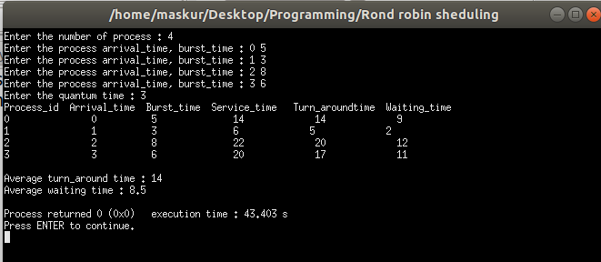

Advantage of Round-robin Scheduling
Here, are pros/benefits of Round-robin scheduling method:
- It doesn't face the issues of starvation or convoy effect.
- All the jobs get a fair allocation of CPU.
- It deals with all process without any priority
- If we know the total number of processes on the run queue, then we can also assume the worst-case response time for the same process.
- This scheduling method does not depend upon burst time. That's why it is easily implementable on the system.
- Once a process is executed for a specific set of the period, the process is preempted, and another process executes for that given time period.
- Allows OS to use the Context switching method to save states of preempted processes.
- It gives the best performance in terms of average response time.

Disadvantages of Round-robin Scheduling
Here, are drawbacks/cons of using Round-robin scheduling:
- If slicing time of OS is low, the processor output will be reduced.
- This method spends more time on context switching
- Its performance heavily depends on time quantum.
- Priorities cannot be set for the processes.
- Round-robin scheduling doesn't give special priority to more important tasks.
- Decreases comprehension
- Lower time quantum results in higher the context switching overhead in the system.
- Finding a correct time quantum is a quite difficult task in this system.
Conclusion : Alhamdullilah Finally I have completed the code implementation of this algorithm. Unlike the previous scheduling algorithm FCFS,SJF it is not easy to me to implement. It takes a multiple hours of time to implement this algorithm. It makes the code few more difficult because of the quantum time .In the above code I use one fixed_burst time variable since the burst time will vary because it will work withing the quantum. Thus we can easily calculate the turn_aruond time and waiting time and average_waiting time .

